Change Request Form

Change Request details
Change Request details
Change Request Title | Enhancements to the Change Control Approach
Change Request Number | CR026
Originating Advisory / Working Group | N/A
Risk/issue reference | N/A
Change Raiser | Alex Whiteman (MHHS Programme) | Date raised: | 28/06/2023

For further guidance on how to complete this document please see the supporting Change Request Form Guidance for Programme Participants. The guidance will support raising a change and responding to a change request via Impact Assessment. The Change Raiser should consider sharing the draft Change Request Form with impacted programme parties, prior to submission to PMO. The guidance, as well as other key documents are referenced below and can be found via the MHHS website.

Change Request to be read in conjunction with:
MHHS Change Request Form Guidance for Programme Participants
MHHS Change Control Approach
MHHS Governance Framework
Ofgem’s MHHS Transition Timetable

Part A – Description of proposed change
Guidance – This section should be completed by the Change Raiser when raising the Change Request.

Part A – Description of proposed change
Issue statement:
(what is the issue that needs to be resolved by the change)

The Programme received feedback from Programme Participants on the Change Control Approach and identified areas where the guidance could be enhanced. This includes:

- Recognising the new Fast Track Design Update Process and links to the Design Issue Notification Log
- The process to follow when the Change Board reject a Change Request
- Greater clarity on the implementation process for approved Change Requests
- The role of the Chair/SRO in the decision-making process
- Greater clarity on the role of Change Board in the Change Control Process
- Greater clarity on the responsibilities of Advisory Groups in the Change Control Process

Description of change:
(what is the change you are proposing)

This is a Housekeeping change which is seeking to make minor enhancements to the Change Control Approach, aligning with current change management activities. A summary of updates to the Programme Change Control Approach is below:

- Add a new major source of change in Overview and scope​, Scope of change on MHHS (p8) ​: A change raised via the design issues process.
- Add a description of the Fast Track Design Update Process and Design Issue Notifications (DINs) Overview and Scope, Different variations of the change process​ (p10): The Fast Track Design Update Process consolidates open items in the DIN Log into a single monthly release of updated design documentation. Items that follow this process do not require a Change Request to be raised, as per the documented process.
Some open items in the DIN Log may be of sufficient complexity that they require further discussion at the Design Review Group (DRG). An output of this session may be to raise a Change Request for Impact Assessment, or to undertake the necessary options analysis via the PPIR process before raising a CR once the chosen solution is agreed.
- Insert a new slide outlining when Change Request should be raised Overview and Scope, When a Change Request should be raised (p11)​:

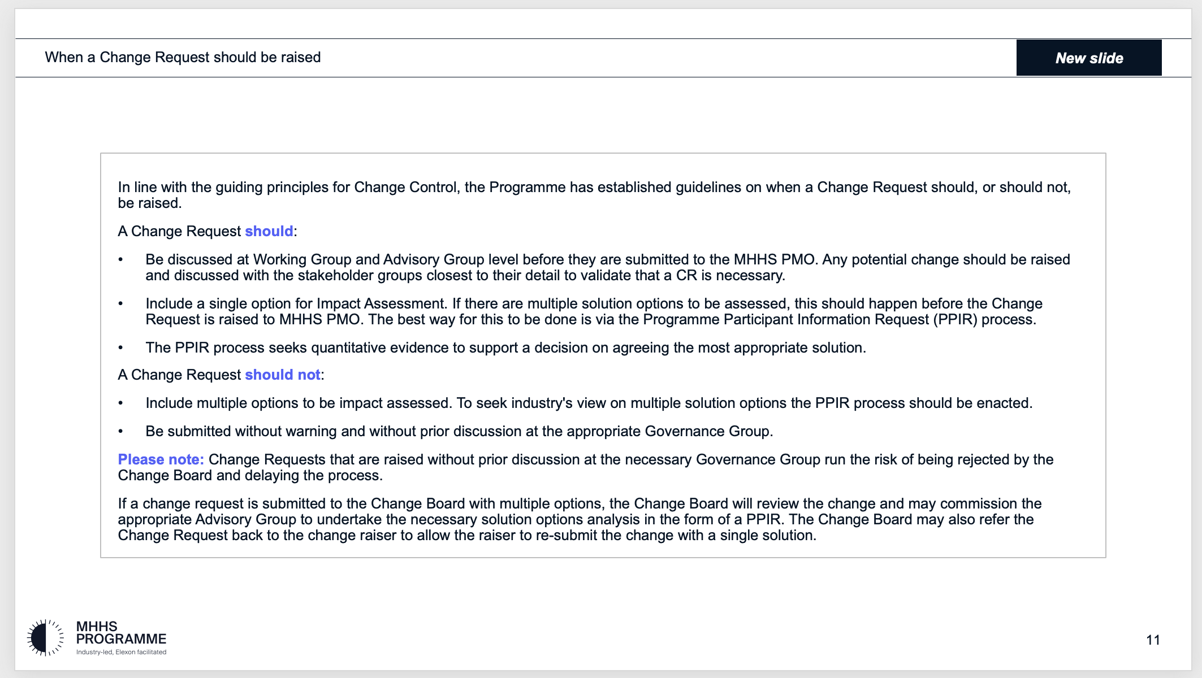
- Insert a new slide outlining the application of the Change Control Process Overview and Scope, Application of the Change Control Process (p12)​:
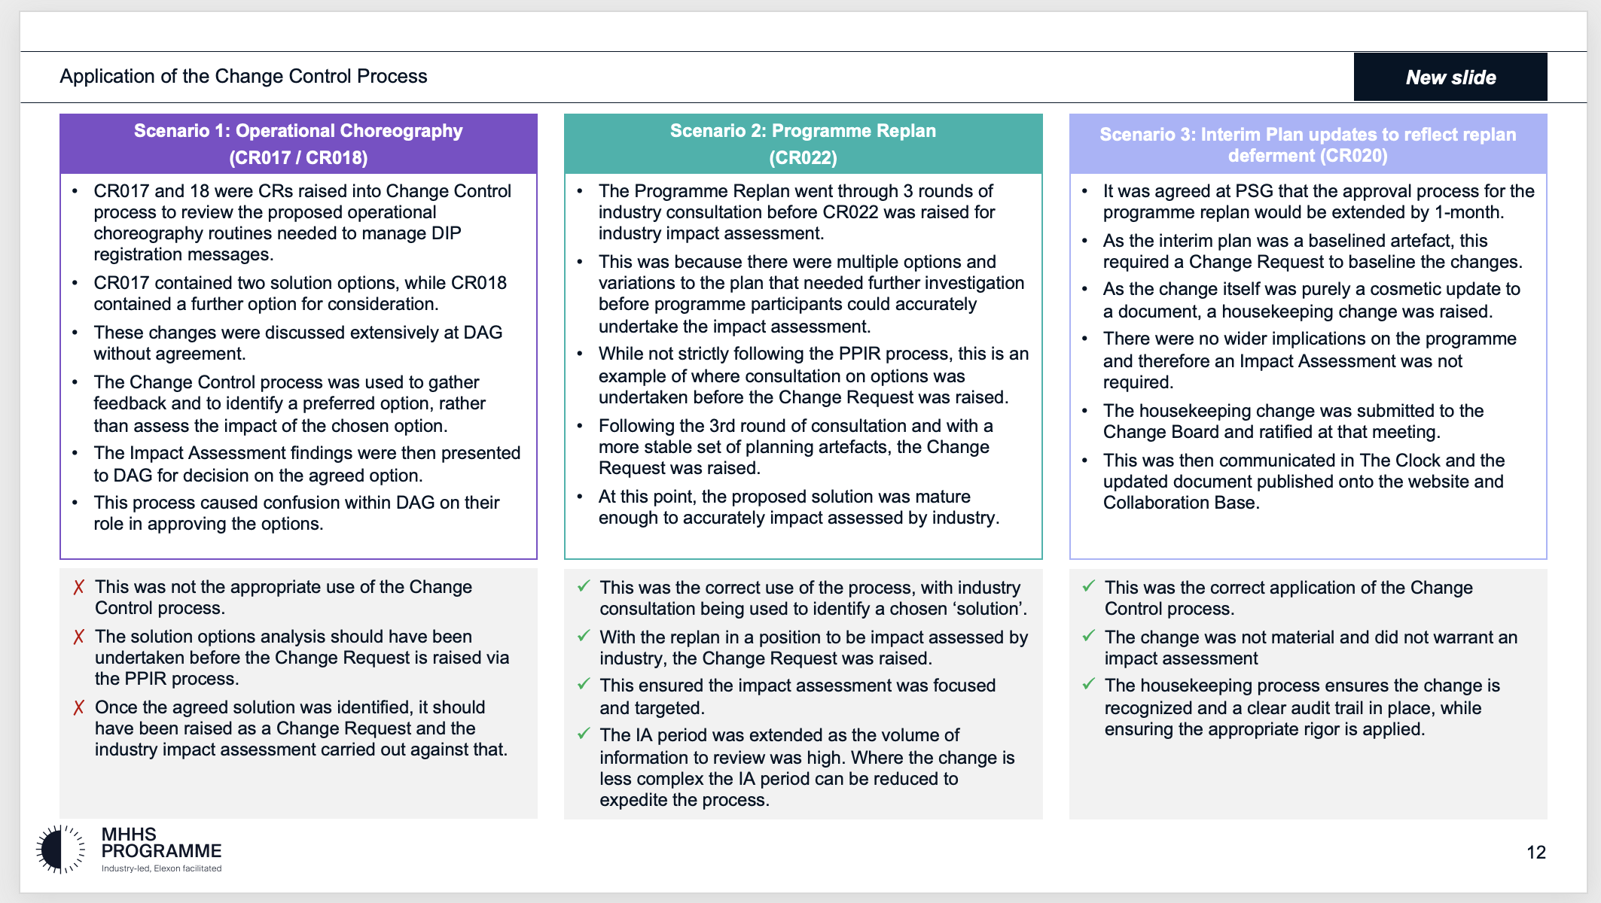
- Add updates to the four key phases of the Change Control Process Approach, Phases of the Change Control Process (p14) ​:
  - This could be submitted directly to the MHHS PMO by a PP (following the process on slide 10), as a result of a DIN submitted to the Design team, an update identified in Code Drafting, or following a formal PPIR.
  - The Change Board and Change Raiser will consider dates required for implementation as part of the validation process.
  - The Change Board may also reject the CR or request further information.
  - If approved, the MHHS PMO communicate this to impacted parties along with implementation timelines.
- Define the role of the Advisory Groups Approach, The role of Advisory Groups and PSG in Change Control (p15): and advising the SRO or Chair on an approval decision.
- Insert a new slide demonstrating the Post-Implementation stage Detailed Process Maps, Post Implementation – Process Map (p21):
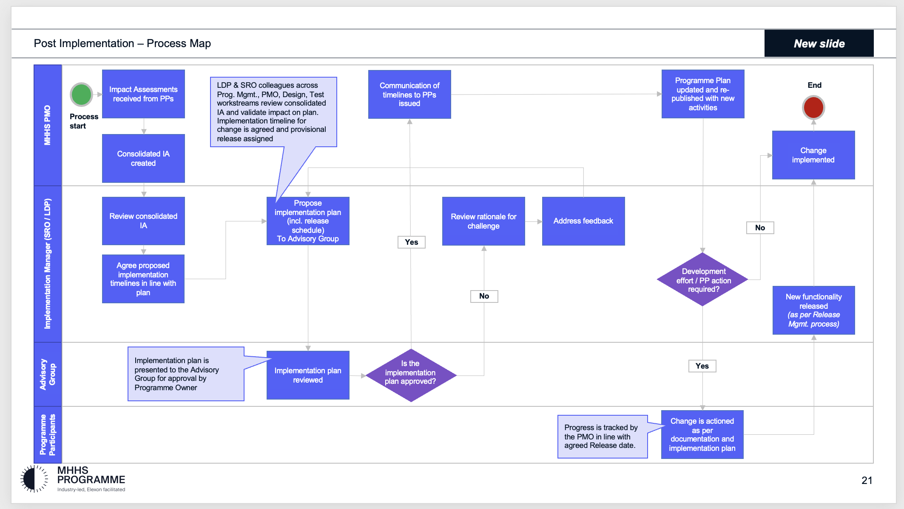
- Insert a new slide demonstrating Horizon Scanning and Managing External Change Detailed Process Maps, Horizon Scanning and Managing External Change (p22):
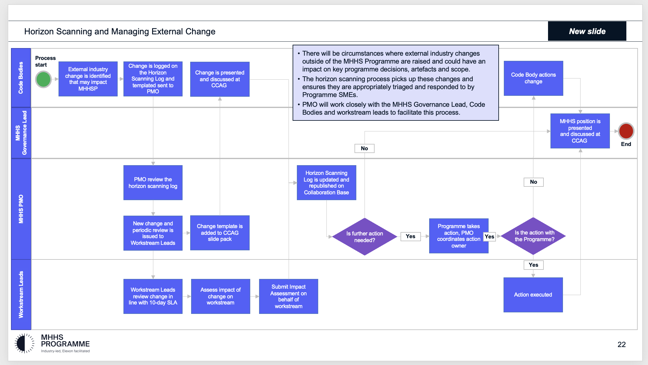
- Insert a new slide detailing the respective responsibilities of the Change Board and Advisory Groups Roles and Responsibilities – Change Board and Advisory Groups (p27):
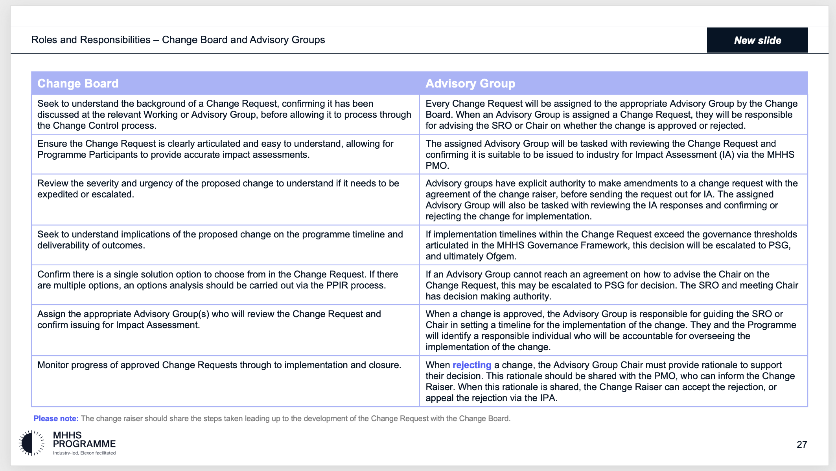

Justification for change:
(please attach any evidence to support your justification)
The updates to the Change Control Approach are required to ensure that the documentation aligns with current change management activities and provides Programme Participants with sufficient guidance when following the process. It ensures that correct processes are followed by all Programme Participants, and removes any confusion and ambiguity surrounding change processes, as well as roles and responsibilities.
The updates also include an outline of the Fast Track Design Update Process and Design Issue Notifications (DINs), which is a new process and therefore requires documentation.

Consequences of no change:
(what is the consequence of no change)
The Programme Change Control Approach will not accurately reflect the decisions of DAG, and latest agreed process, without incorporating the design change process.
The Change Control Approach is a public-facing artefact, available to Programme Participants on the Collaboration Base and MHHS website. Failing to update the Change Control Approach would render the information in the artefact outdated and therefore, unsuitable for publication. Failing to update the artefact could result in a lack of clarity and guidance among Programme Participants.
Alternative options:
(What alternative options or mitigations that have been considered)
None.
Risks associated with potential change:
(what risks related to implementation of the proposed change have been identified)
There is no risk to the Programme through the implementation of this change. This change is intended to mitigate the risk of inefficient or unclear ways of working for MHHS Programme Parties with the MHHS Programme.
Stakeholders consulted on the potential change:
(Please document the stakeholders, or stakeholder groups that have been consulted to date on this change. The Change Raiser should consult with relevant programme parties in the drafting of the request, prior to submission to PMO).
Feedback from Programme Participants has been reviewed and actioned. Workshops have been held with Design Assurance, Code Management and Programme SRO, in order to agree the proposed changes.
Target date by which a decision is required: | 05/07/2023

Part B – Initial Impact of proposed change
Guidance – This section should be completed by the Change Raiser before being submitted to the MHHS PMO.
Please document the benefits of the change and to delivery of the programme objectives

What benefits does the change bring
(list the benefits of the change and how this improves the business case)
Increased clarity and alignment mean the MHHS Programme is more likely to deliver efficiently and economically.

Programme Objective | Benefit to delivery of the programme objective
To deliver the Design Working Group’s Target Operating Model (TOM) covering the ‘Meter to Bank’ process for all Supplier Volume Allocation Settlement meters | This Change Request does not impact the TOM.
To deliver services to support the revised Settlement Timetable in line with the Design Working Group’s recommendation | This Change Request does not impact the revised Settlement Timetable.
To implement all related Code changes identified under Ofgem’s Significant Code Review (SCR) | This Change Request does not impact the Code changes.
To implement MHHS in accordance with the MHHS Implementation Timetable | This Change Request does not impact the final delivery date for MHHS.
To deliver programme capabilities and outcomes to enable the realisation of benefits in compliance with Ofgem’s Full Business Case | This Change Request does not impact the capabilities and outcomes.
To prove and provide a model for future such industry-led change programmes | This Change Request does not impact the model for future industry-led change programmes.

Guidance – Please document the known programme parties and programme deliverables that may be impacted by the proposed change

Impacted areas | Impacted items
Impacted Parties | All Programme Participants, particularly those Programme Parties participating in DAG, and associated governance groups.
Impacted Deliverables | Programme Change Control Approach (MHHS-DEL171)
Impacted Milestones | None.

Note – Please refer to MHHS DEL174 Change Request Guidance for Programme Participants for information on how to score the initial assessment.

Initial assessment
Necessity of change |  | Expected lead time
Rationale of change |  | Expected implementation window
Expected change impact

Guidance – Please include a reference and link to any additional documentation which the change relates to.
Change Request to be read in conjunction with:
Title | Reference
SI Design Management Approach | MHHS-DEL714
Design Change Management Procedure | MHHS-DEL744

Part C.1 – Summary of Impact Assessment

Note – This section will be completed initially by the Change Raiser and then by Programme Participants as part of the full Impact Assessment.

All Impact Assessment responses will be considered public and non-confidential unless otherwise marked. If there are any specific elements of the response (e.g. costs) that are confidential, please mark the specific sections as confidential rather than the response as a whole. The MHHS Programme will publish all Impact Assessment responses and redact any confidential information as noted.
Guidance – Programme Participants are required to:
- Respond with ‘Agree’, ‘Disagree’ or ‘Abstain’, deleting as appropriate. If the respondent agrees, they can provide additional evidence to further support the assessment. If the respondent disagrees or abstains, they should provide a detailed rationale as to why.

- Add any additional effects that have not already been identified. In doing so, they should provide as much detail as possible to allow a robust assessment to be made.

- Proceed to Part C.2 for Impact Assessment Recommendation response once completed.

Part C.1 – Summary of Impact Assessment (complete as appropriate)
Effect on benefits
Change Raiser to provide initial impact assessment.

<Delete as appropriate>: Agree Disagree Abstain
Impact Assessment respondents to add supporting commentary to support their selection. Where possible, Impact Assessment respondents to identify and describe any further impacts.
Impact Assessment respondents should consider and provide detail of any additional effect e.g. whether there will be an impact on when a benefit will be realised; who will realise the benefit; the extent to which the benefit will be realised.
Where possible, contextual information should be included e.g. the benefit will be delayed by X weeks; the change means Y population will also realise the benefit.
Effect on consumers
Change Raiser to provide initial impact assessment.

<Delete as appropriate>: Agree Disagree Abstain
Impact Assessment respondents to add supporting commentary to support their selection. Where possible, Impact Assessment respondents to identify and describe any further impacts.
Impact Assessment respondents should consider and provide detail of any additional effect e.g. whether there will be an impact on service delivery to consumers; will there be a cost impact to consumers; will there be a choice impact to consumers?
Where possible, contextual information should be included e.g. what is the scale of the effect? Will the effect be permanent?
Effect on schedule
Change Raiser to provide initial impact assessment.

<Delete as appropriate>: Agree Disagree Abstain
Impact Assessment respondents to add supporting commentary to support their selection. Where possible, Impact Assessment respondents to identify and describe any further impacts.
Impact Assessment respondents should consider and provide detail of any additional effect e.g. will the schedule/milestones be directly impacted; will the schedule/milestones be indirectly impacted.
Where possible, contextual information should be included e.g. the change will delay the project by X days; the change will require additional resource to complete (though detail resource in resource section); the delay can/cannot be recovered by condensing Y activity.
Effect on costs
Change Raiser to provide initial impact assessment.

<Delete as appropriate>: Agree Disagree Abstain
Impact Assessment respondents to add supporting commentary to support their selection. Where possible, Impact Assessment respondents to identify and describe any further impacts.
Impact Assessment respondents should consider and provide detail of any additional effect e.g. will the change cause a loss of income; will the change cause additional cost; will the change cause a reprofiling of cost?
Where possible, contextual information should be included e.g. whether it is capital or operating expenditure that will be affected; what period costs will be affected in; what the rough order of magnitude of the cost impact will be and if organisation will be able to absorb it?
Effect on resources
Change Raiser to provide initial impact assessment.

<Delete as appropriate>: Agree Disagree Abstain
Impact Assessment respondents to add supporting commentary to support their selection. Where possible, Impact Assessment respondents to identify and describe any further impacts.
Impact Assessment respondents should consider and provide detail of any additional effect e.g. will there be an impact on tools or equipment; will there be an impact on staff capacity; will there be an impact on staff skills or capability?
Where possible, contextual information should be included e.g. the change will require X additional staff for Y period of time; the change requires Z training or support.
Effect on contract
Change Raiser to provide initial impact assessment.

<Delete as appropriate>: Agree Disagree Abstain
Impact Assessment respondents to add supporting commentary to support their selection. Where possible, Impact Assessment respondents to identify and describe any further impacts.
Impact Assessment respondents should consider and provide detail of any additional effect e.g. whether there will be an impact on contracts with sub-contractors; whether there will be an impact on contracts with vendors; whether there will be an impact on contracts with regulators/ESO.
Where possible, contextual information should be included e.g. the changes will require new contracts to be created; the changes will variations to existing contracts; the changes will affect ability to meet contract requirements.
Risks
Change Raiser to provide initial impact assessment.

<Delete as appropriate>: Agree Disagree Abstain
Impact Assessment respondents to add supporting commentary to support their selection. Where possible, Impact Assessment respondents to identify and describe any further impacts.
Impact Assessment respondents should consider and provide detail of any additional effect e.g. will existing risks be affected; will new risks be created?
Where possible, contextual information should be included e.g. the change will affect the likelihood of a risk occurring, the change will affect the impact the risk would have, the change will require additional controls and mitigation.

Part C.2 – Impact Assessment Recommendation

Note – This section must be completed initially by the Change Raiser and then by Programme Participants as part of the full Impact Assessment.
Guidance – The primary reporting metric of the Impact Assessment is the recommendation response. The consolidated response will be presented to the relevant governance group(s) and decision maker(s) with the totals for ‘Agree’, ‘Disagree’ or ‘Abstain’. As such, please ensure this section is completed before the form is returned to MHHS PMO. Provide detailed rationale and evidence in the commentary field.

Part C.2 – Impact Assessment Recommendation (mandatory)
Recommendation
Change Raiser to provide initial recommendation.
It is recommended by the Change Raiser the change is approved.
<Delete as appropriate>: Agree Disagree Abstain
Impact Assessment respondents to add supporting commentary to support their selection.

Impact assessment done by: <Name>

Guidance: If you are a third party responding on behalf of another Programme Participant, please state this in your response.

Impact assessment completed on behalf of: <Name>

Part D – Change approval and decision
Guidance: The approvals section will be completed by the MHHS PMO once the Impact Assessment has been reviewed.

Part D - Approvals
Decision authority level
<Based on the impact assessment, state who is required to make a decision concerning this change>

Guidance - This section will be completed by the MHHS PMO and Change Owner following the review of the impact assessment and decision reached by the SRO.

Part D – Change decision
Decision: |  | Date
Approvers:
Change Owner:
Action:
Changed Items | Pre-change version |  | Revised version

Part E – Implementation completion
Guidance - This section will be completed by the MHHS PMO at the end of the post-implementation process.

Part E – Implementation completion
Comment |  | Date

Guidance – The Closure Checklist in MHHS DEL175 Change Log must also be completed by MHHS PMO at this stage.

Checklist Completed | Completed by
Yes/No

Guidance – This section will be completed by the MHHS PMO at the end of the post-implementation process and should be used to add any appropriate references of the change once it has been completed.

References
Ref | Document number | Description

